Assiut University

Faculty of Computers & Information

Department of …

**Graduation Project**

**Academic Year 2022-2023**

Recona

Project Proposal

Analysis of cell composition from tissue expression profiles and identification of infection with lynch syndrome

Project Proposal

Project Team

Mariam Adel Abdelrazik – 1620195248

Marwa Gamal Salman – 1620195253

Marwa Kamal Badri – 1620195246

Mai Ramadan Mohamed – 1620195269

Ayat Saber Mohamed – 1620195056

Amira Emad Abdelhamid – 1620195053

Maha Mamdouh Adli – 1620195265

Supervisor

Prof. Mostafa Kamel

**2022**

Table of Contents

Project Abstract 3

Project Objectives 3

Approaches and Methodology 3

Project Plan and Management 4

References 5

# Project Abstract

We perform RNA analysis of an unknown cell, using deep learning algorithms, the tissue type is determined, and after further investigation, it is revealed that there are mutations in the following genes (MLH1, MSH2, MSH6, PMS2, and EPCAM) gene Those on chromosomes number 2, 3, 5, and 7 thus it can be detected that the patient has Lynch syndrome. This genetic disorder increases the risk of many types of cancer, especially colon and endometrial cancer. Thus, it is possible to predict the patient's risk of contracting these cancers.

# Project Objectives

Our proposed project is supposed to meet these objectives:

Identifying the cellular composition of tissues and chromosomes using a deep neural network for cell deconvolution that uses gene expression information and detecting lynch syndrome (inherited cancer syndrome associated with a genetic predisposition to different cancer types).

# Approaches and Methodology

Using a specific dataset, (front & back) web development and machine learning:

at first, we use an RNA sequence from an unknown cell, and we identify through a deep learning algorithm the type of tissue that is specific to the cell, and then we detect by an algorithm that searches for whether this tissue is susceptible to lynch syndrome.

# Project Plan and Management

Phase 1: 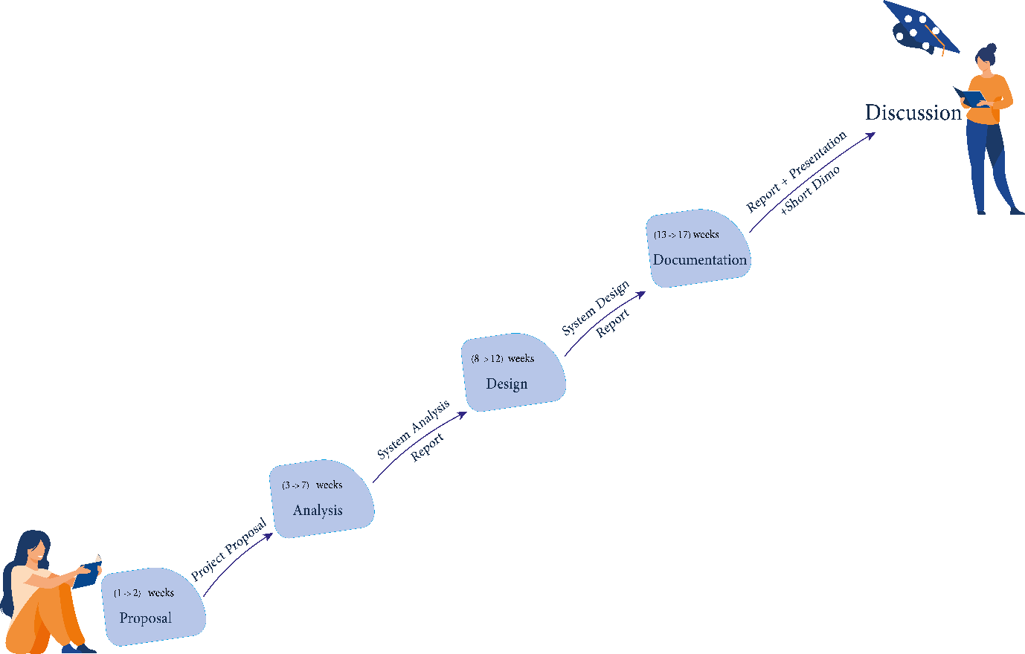

# References

1. <https://scaden.readthedocs.io/en/latest/>
2. <https://www.cancer.net/navigating-cancer-care/cancer-basics/genetics/genetics-cancer>
3. <https://www.cancer.net/cancer-types/lynch-syndrome>